

19p0012 Aitzaz tahir ch

DATA BASE LAB 03



**Task 3.1 Suppose the owners of all the theme parks wanted to compare the current ticket**

**prices, with an increase in the price of each ticket by 10%. To generate this query type:**

SELECT PARK_CODE, TICKET_NO, TICKET_TYPE,

TICKET_PRICE, TICKET_PRICE + ROUND((TICKET_PRICE *0.1),2)

AS "PRICE INCREASE"

FROM TICKET;

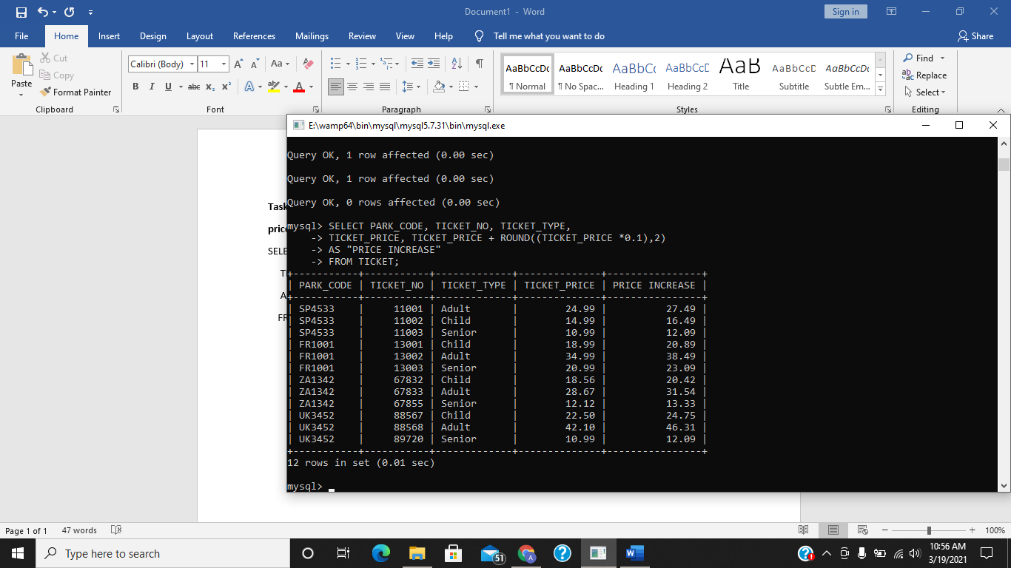

**Task 3.2 Type in and execute the query and test out the greater than operator. Do you get the same results has shown in Figure 20?**

Yes as u can see below

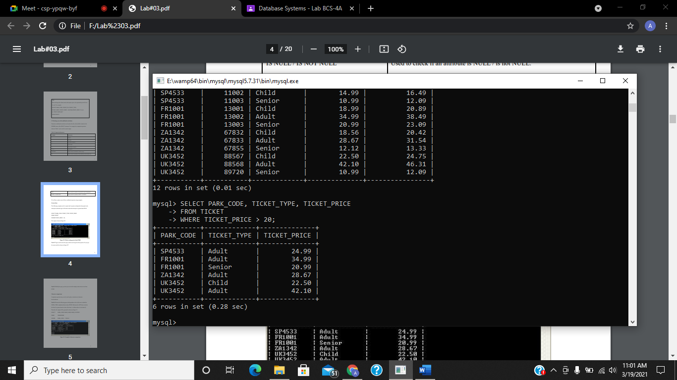

**Task 3.3 Modify the query you have just executed to display tickets that are less than €30.00.**

SELECT PARK_CODE, TICKET_TYPE, TICKET_PRICE

FROM TICKET

WHERE TICKET_PRICE < 30;

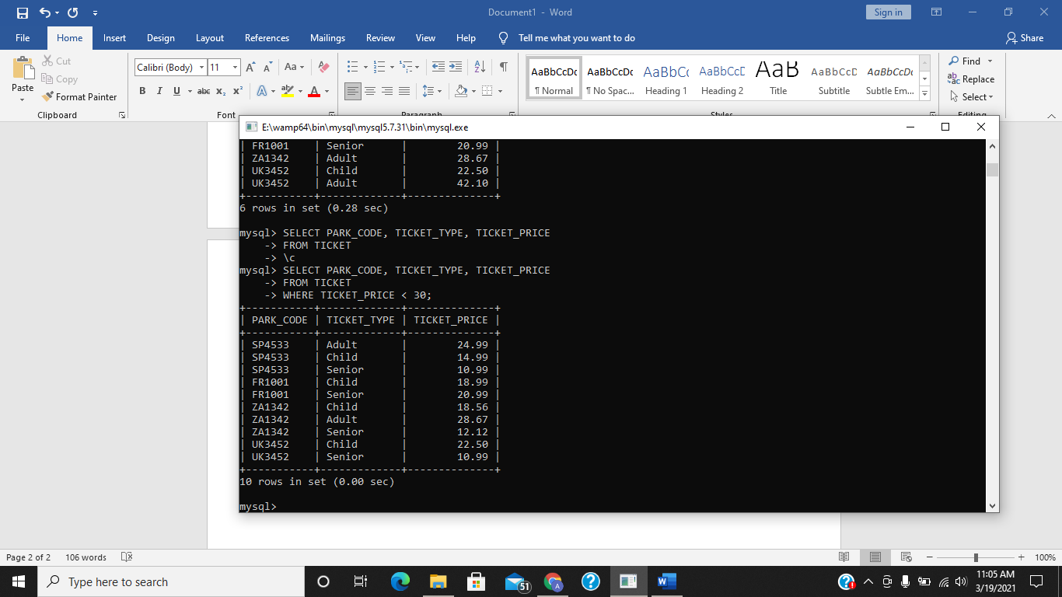

**Task 3.4 Execute the following query which produces a list of all rows in which the PARK_CODE is alphabetically less than UK2262. (Because the ASCII code value for the letter B is greater than the value of the letter A, it follows that A is less than B.)**

select park_code, park_name, park_country from themepark where park_code < 'UK2622';

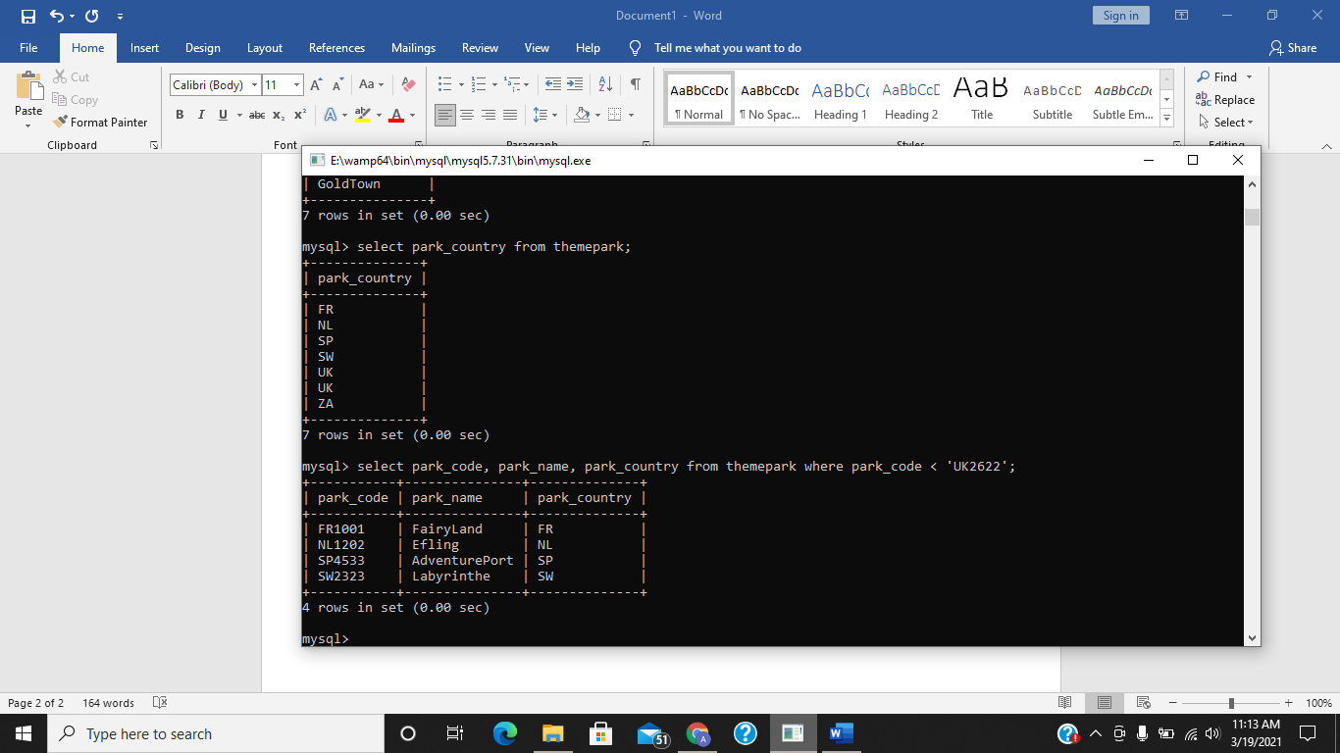

**Task 3.5 Write a query which displays the employee number, attraction no, the hours worked per attraction and the date worked where the hours worked per attraction is between 5 and 10. Hint you will need to select data from the HOURS table. The output for the query is shown in Figure 23.**

select emp_num, attract_no, hours_per_attract from hours where hours_per_attract between 5 and 1;

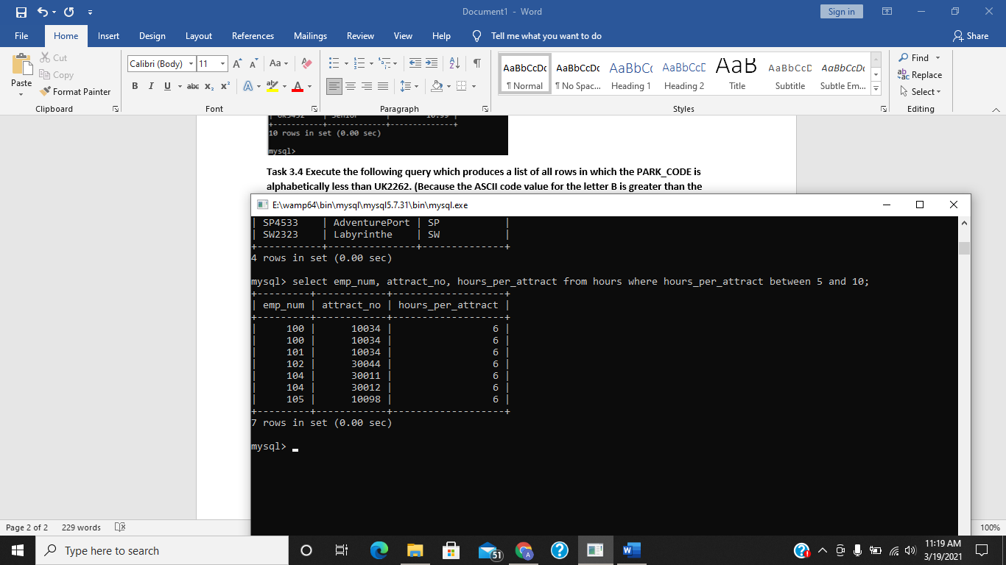

**Task 3.6 Write a query to display all tickets that are of type Senior or Child.**

select * from ticket where TICKET_TYPE in ('Child', 'Senior');

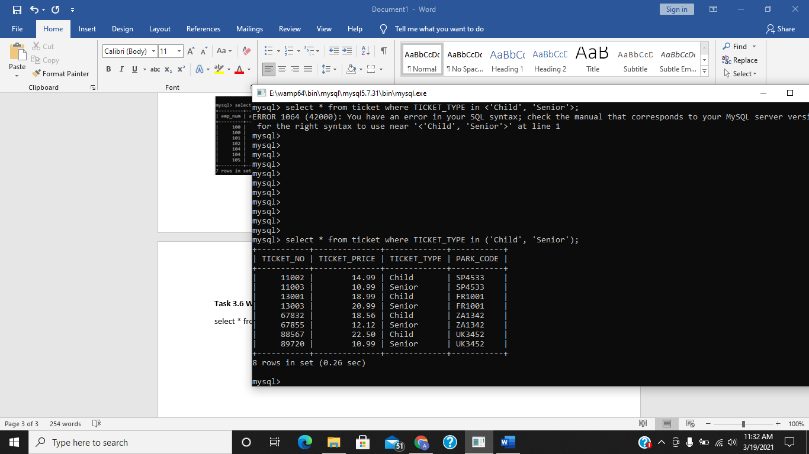

**Task 3.7 Enter the following query which finds all EMPLOYEE rows whose first names begin with the letter A.**

SELECT EMP_LNAME, EMP_FNAME, EMP_NUM

FROM EMPLOYEE

WHERE EMP_FNAME LIKE 'A%';

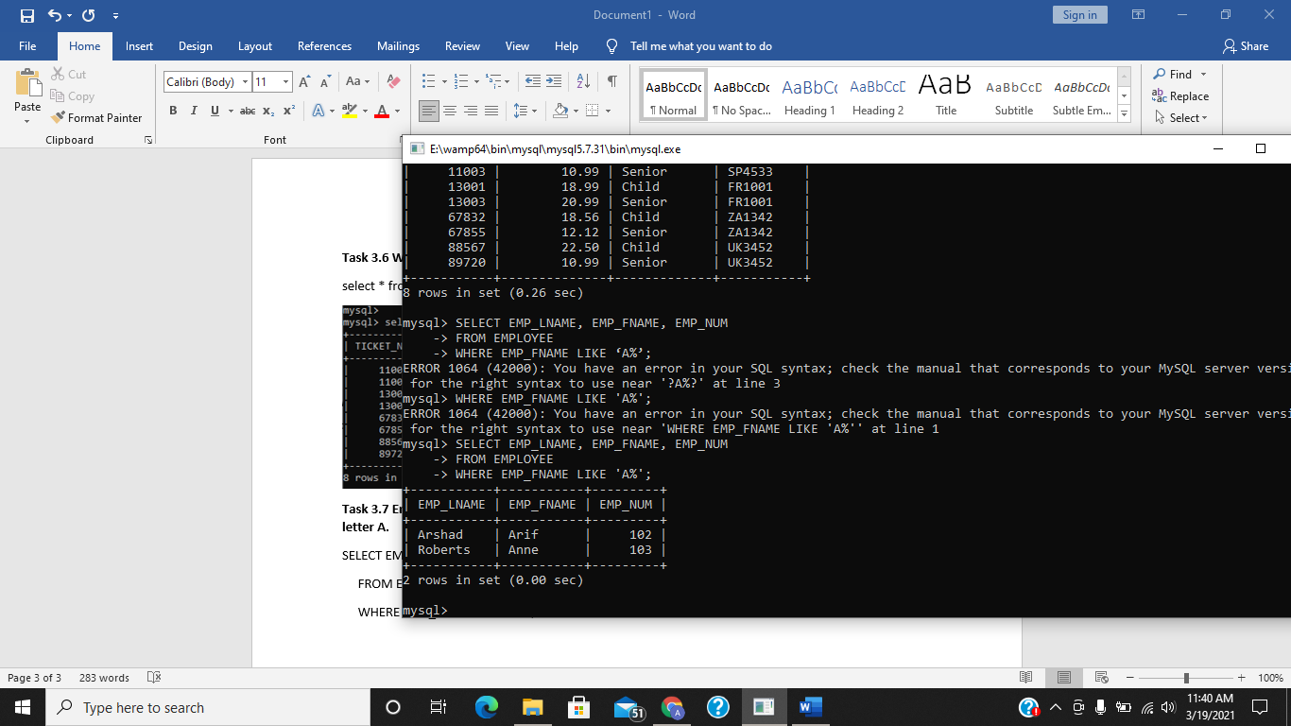

**Task 3.8 Write a query which finds all Theme Parks that have a name ending in ‘Land’. The output you should see is shown in Figure 27.**

select * from themepark where park_name like '%Land';

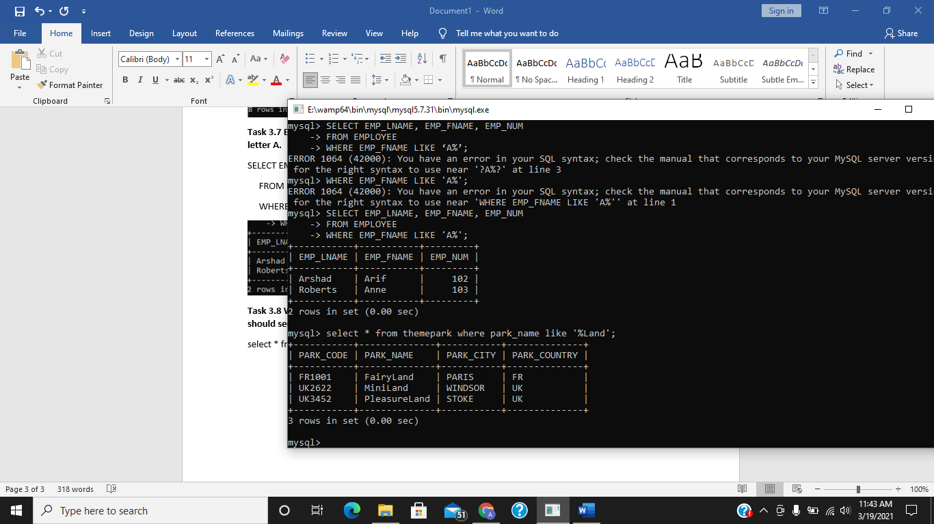

**Task 3.9 Enter the query above and check you results with those shown in Figure 29.**

SELECT EMP_NUM, ATTRACT_NO FROM HOURS WHERE HOURS_PER_ATTRACT > 3 AND DATE_WORKED > '2007-05-18';

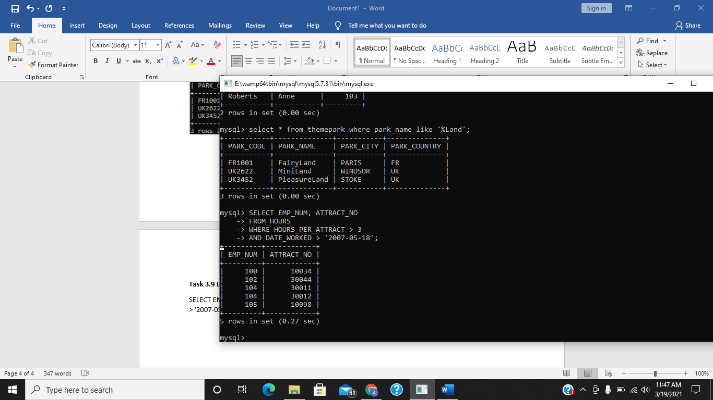

**Task 3.10 Write a query which displays the details of all attractions which are suitable for children aged 10 or under and have a capacity of less than 100. You should not display any information for attractions which currently have no name.**

select * from attraction where attract_age <= 10 and attract_capacity < 100 and attract_name is not null;

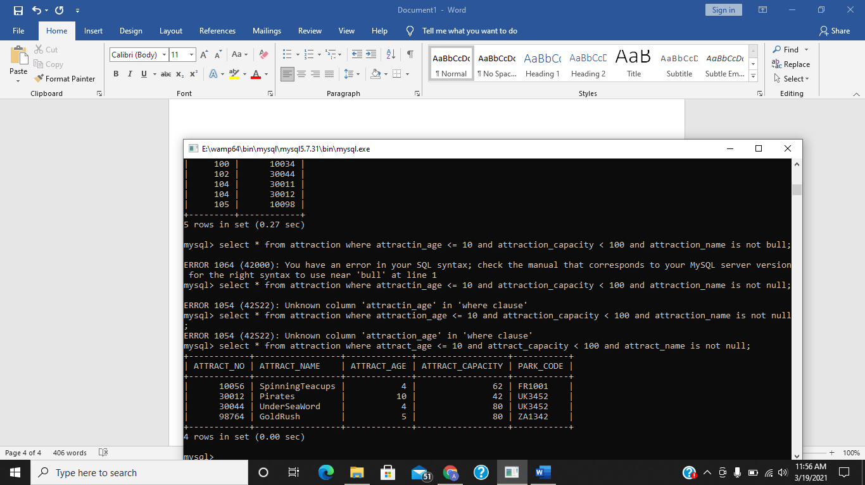

**Task 3.11 Test the following query and check your output with that shown in Figure 32.**

SELECT *

FROM ATTRACTION

WHERE (PARK_CODE LIKE 'FR%'

AND ATTRACT_ CAPACITY < 50) OR (ATTRACT_CAPACITY > 100);

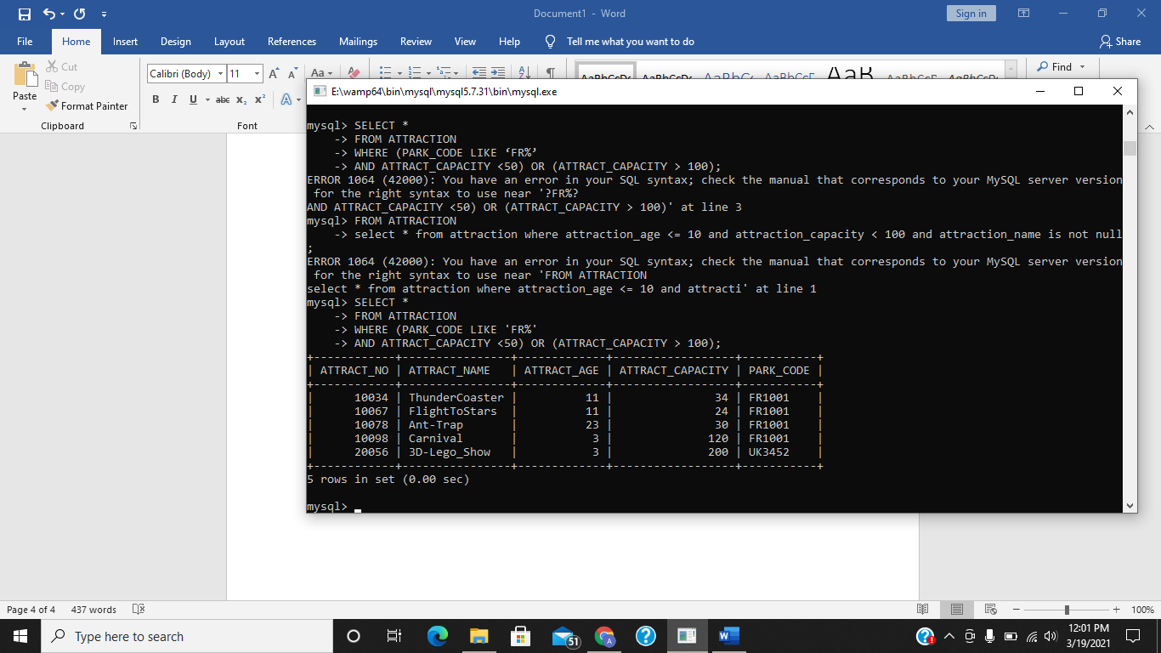

**Can you work out what this query is doing?**

This query is showing us data **PARK_CODE**  starting with **FR**  and having **ATTRACT_ CAPACITY** less than 50 or greater than 100.

**Task 3.12 Enter the following query which contains an example of a cascading order sequence, by ordering the rows in the employee table by the employee’s last then first names.**

SELECT * FROM EMPLOYEE ORDER BY EMP_LNAME, EMP_FNAME;

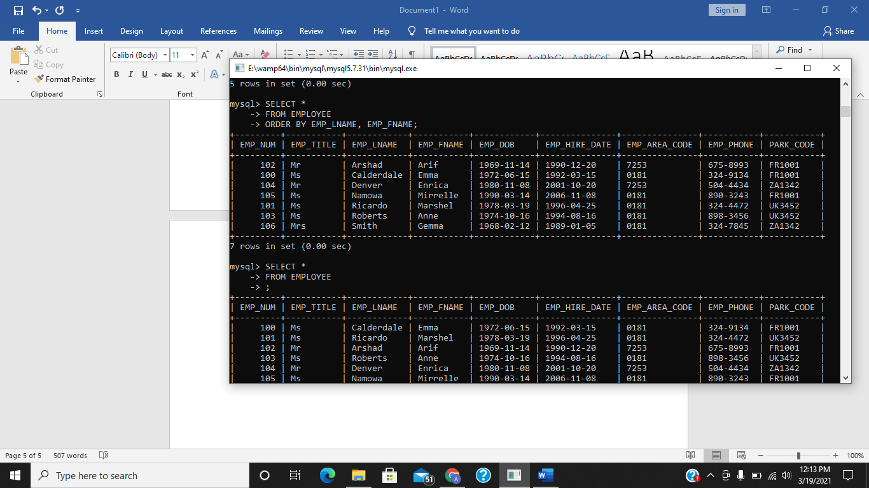

**Task 3.13 Enter the following query and check your output against the results shown in Figure 35.**

SELECT TICKET_TYPE, PARK_CODE FROM TICKET WHERE (TICKET_PRICE > 15 AND TICKET_TYPE LIKE 'Child') ORDER BY TICKET_NO DESC;

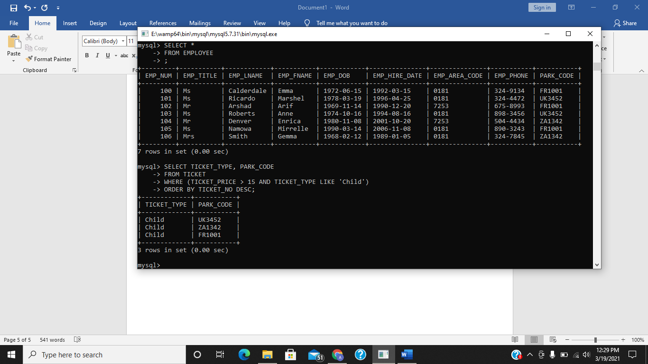

**Describe in your own words what this query is actually doing.**

This query is showing us data of columns TICKET_TYPE, PARK_CODE in which TICKET_PRICE is greater then 15 and type of ticket is ‘Child’ and is sorting ticket in descending order.

**Exercises**

**E3.1 Write a query to display all Theme Parks except those in the UK**

select * from themepark where not(park_country = 'UK');

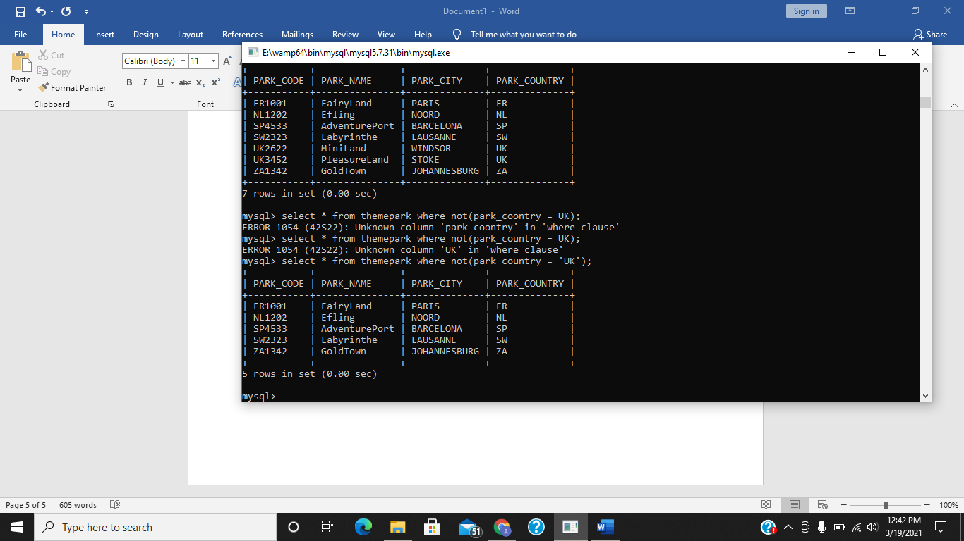

**E3.2 Write a query to display all the sales that occurred on the 18th May 2007.**

select * from sales where sale_date = '2007-05-18';

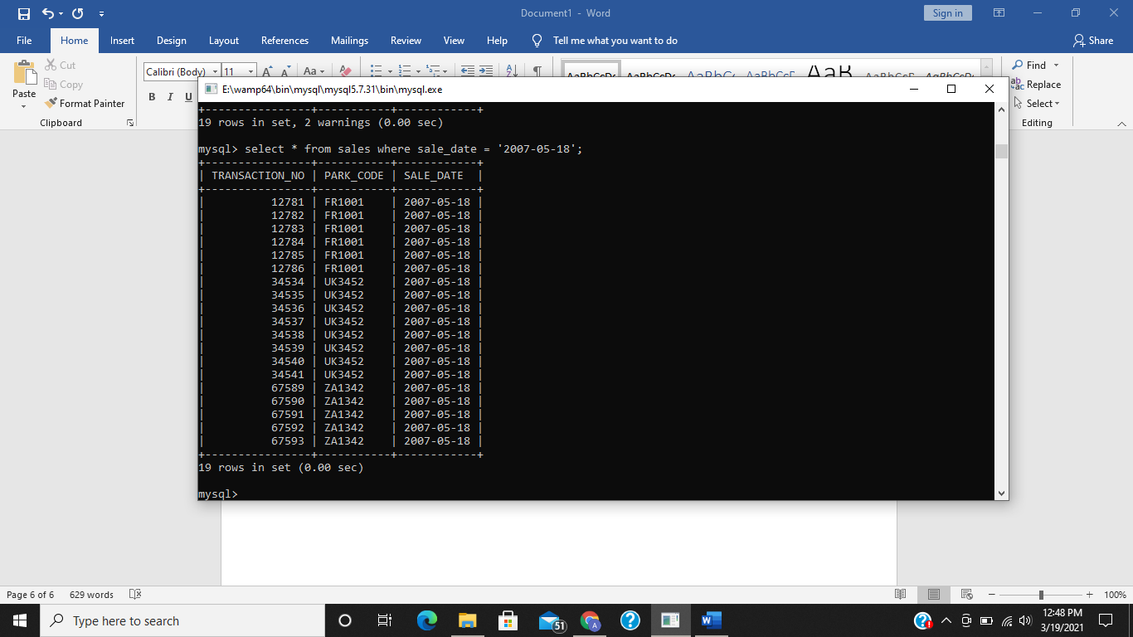

**E3.3 Write a query to display the ticket prices between €20 AND €30.**

select ticket_price from ticket where ticket_price between 20 and 30;

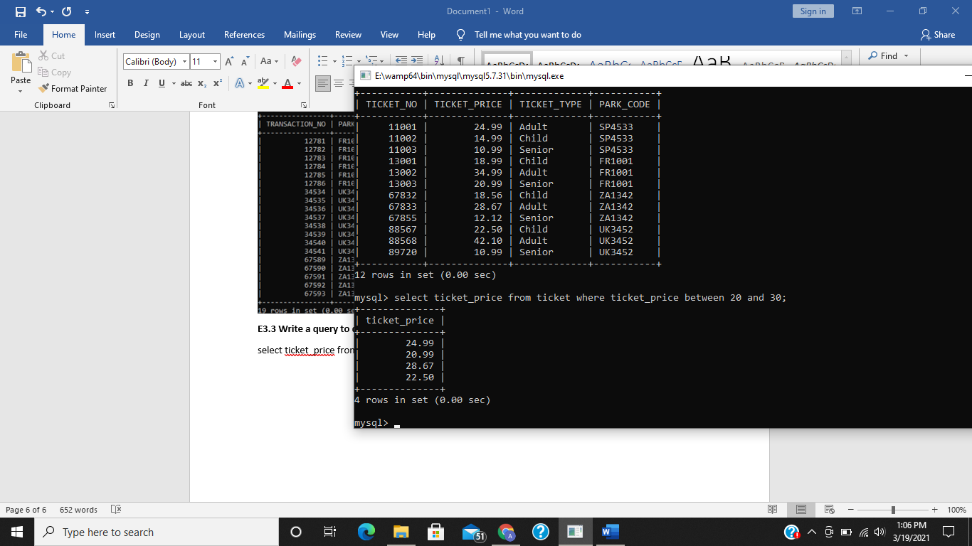

**E3.4 Display all attractions that have a capacity of more than 60 at the Theme Park FR1001**

select attract_no, attract_name from attraction where attract_capacity > 60 and PARK_CODE = 'FR1001';

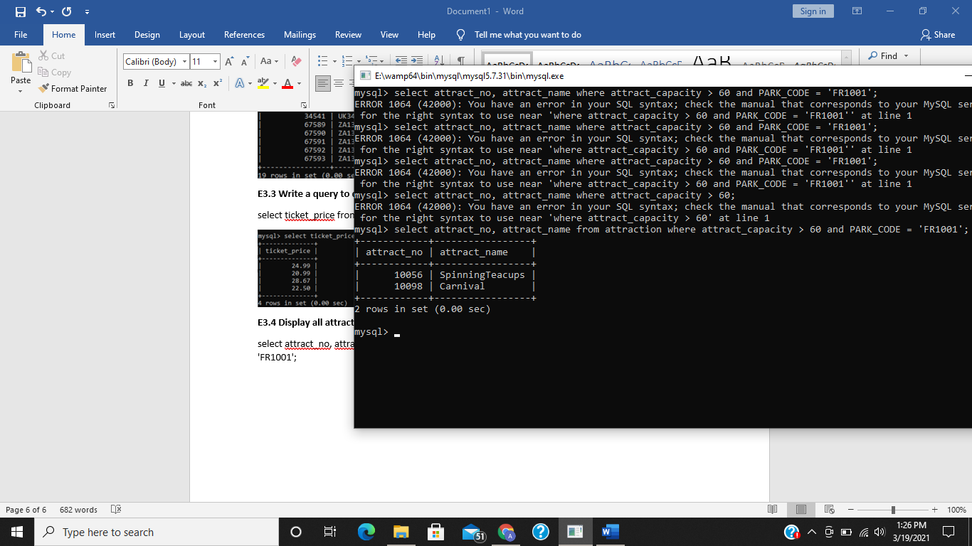

**E3.5 Write a query to display the hourly rate for each attraction where an employee had worked, along with the hourly rate increased by 20%. Your query should only Display the ATTRACT_NO, HOUR_RATE and the HOUR_RATE with the 20% Increase.**

select attract_no, hour_rate, hour_rate + ROUND((hour_rate * 0.2),2) as "new_hour_rate" from hours;

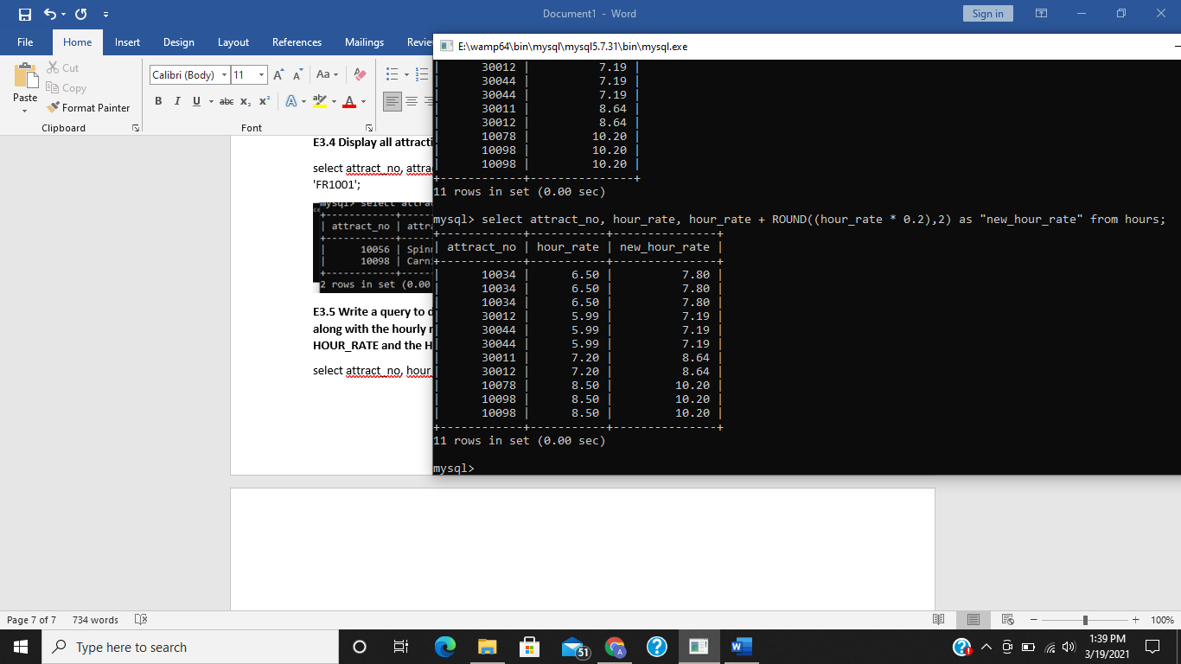

**E.3.6 Elaborate Difference IN vs BETWEEN operators with examples.**

Differences between these operator is that the BETWEEN operator is used to select a range of data between two values while The IN operator allows you to specify multiple values.

**BETWEEN** **Operator**

The BETWEEN operator selects a range of data between two values. The values can be numbers, text,etc.

**Example**

SELECT *FROM akash1

WHERE marks BETWEEN 50 AND 80

**IN** **Operator**

The IN operator allows you to specify multiple values.  
**Example**

SELECT * FROM data

WHERE marks IN (89,81)

**E.3.7 Write a query to display all unique employees that exist in the HOURS table.**

select distinct(emp_num) from hours;

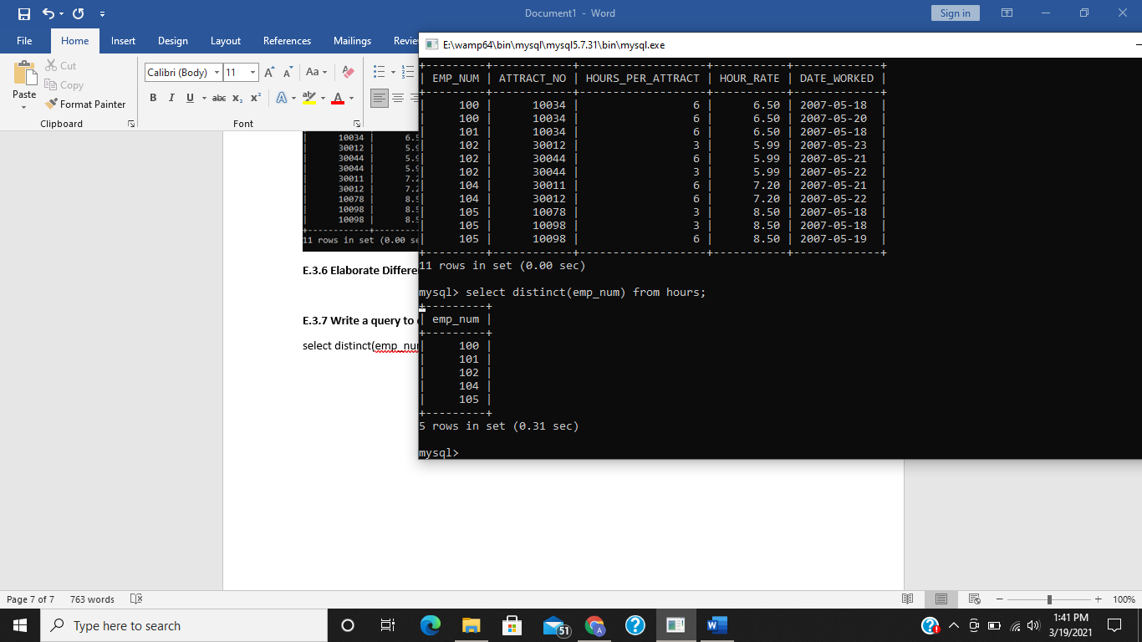

**E.3.8 Display all information from the SALES table in descending order of the sale date.**

select * from sales order by sale_date desc;

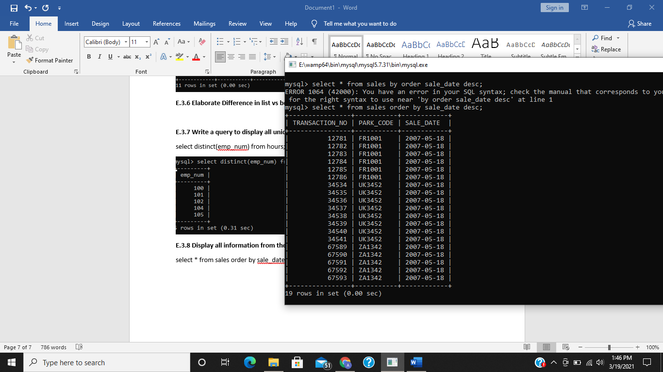

**E.3.9 Write a query to show the transaction numbers and lineprices (in the SALES_LINE table) that are greater than €50.**

select transaction_no, line_price from sales_line where (transaction_no > 50) and (line_price > 50);

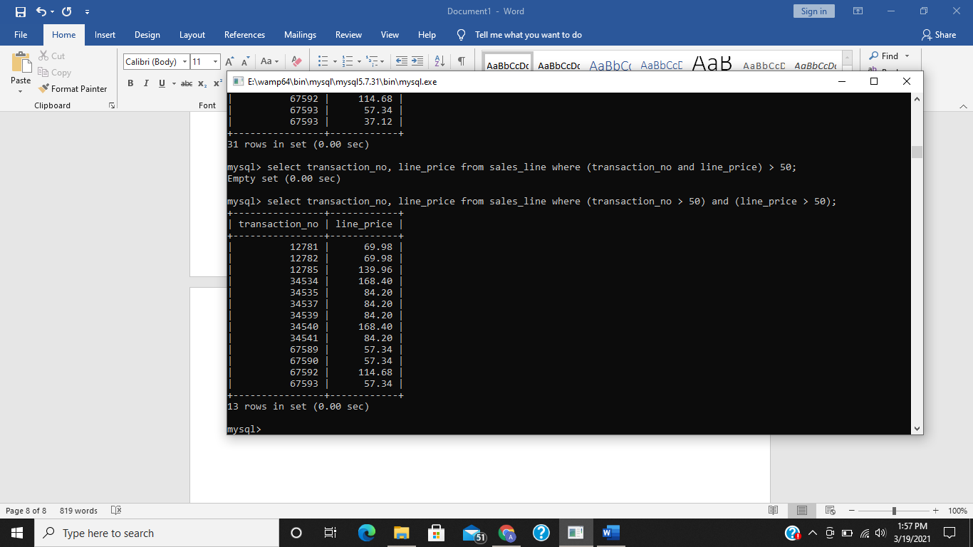

**E.3.10 Write a query to display only the last two Employee Record (EMP_NUM,EMP_FNAME) in descending order.**

select emp_num, emp_fname from employee order by emp_num desc, emp_fname desc;

